Simple Pachislo hopper coin counter

Robert DiNapoli - 2025 - rjgee@hotmail.com

Preface:

I needed to count several thousand quarters in stacks of 40 for rolling in coin sleeves. I know coin counters are cheap these days. You can pick up a Vevor or comparible cheap unit for around $60. And they will even sort the coins for you. However, I couldn't really justify buying a coin counter when I'm probably only going to need it 1 time in my life.

Enter a hopper from a Japanese Pachislo machine, an Arduino, and about 2 hours time, and I have a one time use coin counter. It's quick and dirty. But works.

Need:

- Pachislo Hopper – I'm using one from a Sammy unit (Juki JSH777). Most hoppers will be similar, but you'll need to figure out the wiring on your own.
- External power supply to power the hopper. Anything between 7vdc and 12vdc seems to work well.
- Arduino Relay unit
- Switch to trigger count start
- Arduino – I'm using a mega, but almost any Arduino should suffice as we don't need a lot of inputs / outputs.

Usage:

Before uploading to your Arduino, on line 27, adjust coinsToCount to whatever number you want the unit to spit out before stopping.

Press the switch, and the hopper motor will activate. It will stop when it has reached the proper number of coins, or after 3 seconds of not detecting a coin ejected (hopper empty?)
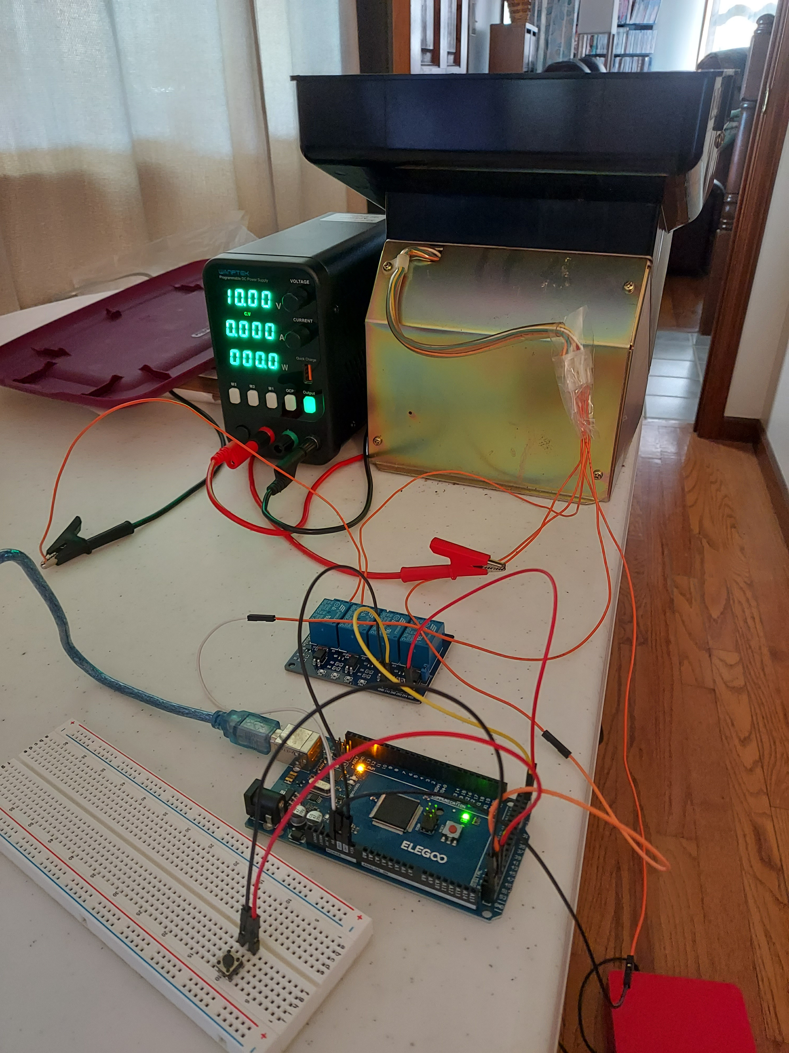

Build:

Switch:
- Wire up your switch one end to ground on the Arduino, and the other end to pin 51 on the Arduino.

Let's talk about the pachislo hopper for a moment. These Juki ones are pretty simple. The motor is activated by the red and white wires. And then there are 2 switches. We're only going to use 1 switch for this project – the normally closed switch. (you could use either switch, possibly with a small code adjustment). If you spin the coin dial by hand, you can see the metal bar swing up from one switch, and enter the 2nd switch when a coin is ejected. We are going to trigger and do a count every time the metal bar leaves it's switch. These switches have 3 wires: 5v, ground, and the signal. The orange wire gets +5v, The green wire gets ground, and the brown (or yellow) wires carry the signal when triggered.
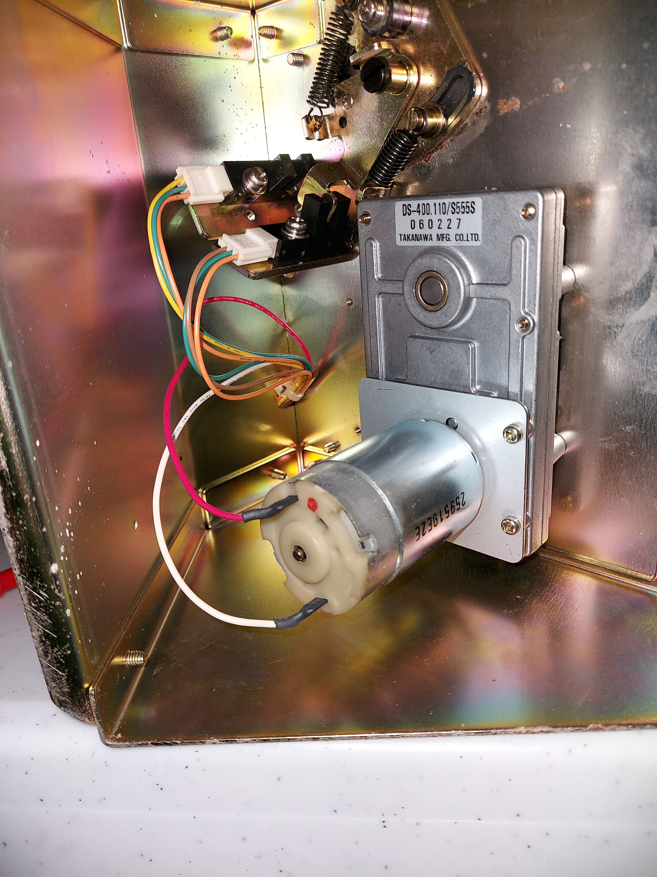

Relay unit to Arduino:
- Wire pin 23 on the Arduino to pin IN1 on the relay unit
- Wire ground from the Arduino to ground on the relay unit
- Wire +5v from the Arduino to vcc on the relay unit

Relay unit to hopper / power supply:
- Wire ground from the external power supply, to the middle pin on the relay unit (common)
- Wire positive (10v or so) from the external power supply, to the red wire on the hopper unit
- Wire the white wire (motor) from the hopper unit to to the rightmost pin NO (normally open) on the relay unit.

Hopper unit to Arduino:
- Wire +5v from the Arduino to the orange wire on the normally closed switch on the hopper unit
- Wire ground from the Arduino to the green wire on the normally closed switch on the hopper unit
- Wire pin 18 from the Arduino to the brown wire on the normally closed switch on the hopper unit

Notes:
The pachislo hoppers are rated for 24vdc, and will spit out coins very fast when used at that voltage. However, I can't seem to get the Arduino code optimized enough to be accurate when the hopper is spinning that fast. I made a quick try at trying the switch based on an interrupt, but still couldn't get it 100%. I can get it close, but not 100%. I'd rather it spit out the coins a bit slower and be accurate since these are going to my bank :) 7 – 12v seem to be optimal. Anything higher and it's possible to miss a coin.

